

Uploader

**Backend**

Uploader.1.0 / 30-Sep-2024

Record of Release

|  |  |  |  |  |  |
| --- | --- | --- | --- | --- | --- |
| **Version No.** | **Modified By** | **Reviewed By** | **Authorized By** | **Release Date** | **Modification Done** |
| 1.0 | Kshitij Mawale |  |  |  | Created complete document |
| 2.0 | Sirichandana Godavarthi |  |  | 27.09.2024 | Added SQL setup |

Table of Contents

1. Key vault Configurations 1

2. Setting up Azure Data Bricks 1

3. ADF Setup 1

4. SQL Setup 1

5. RITM’s raised for whitelisting 1

6. Issues 1

# Key vault Configurations

**For setting up key vaults and secret values following steps need to be created**

Step 1. Search for keyvaults in azure portal

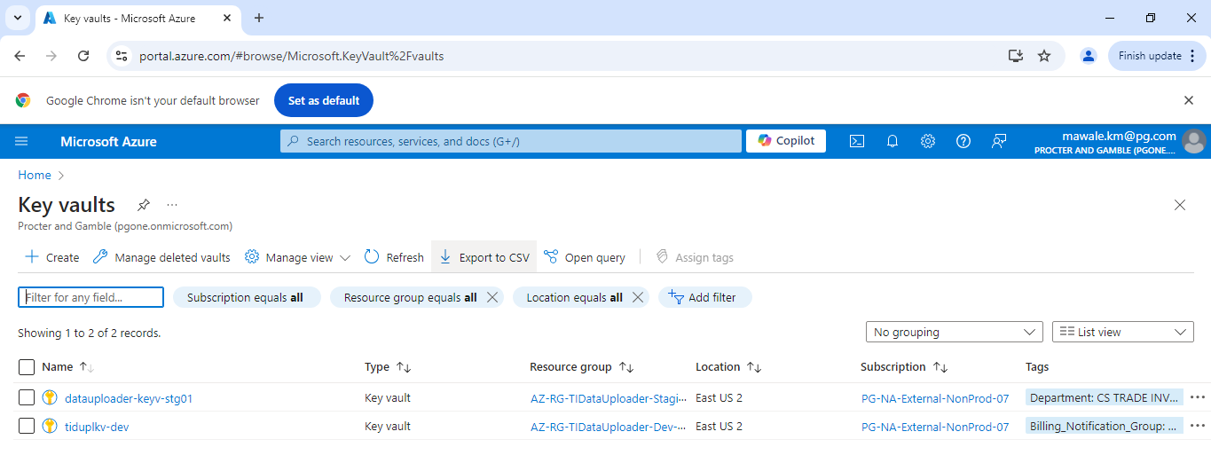

Step 2. Select desired environment, we are selecting Stage for eg.

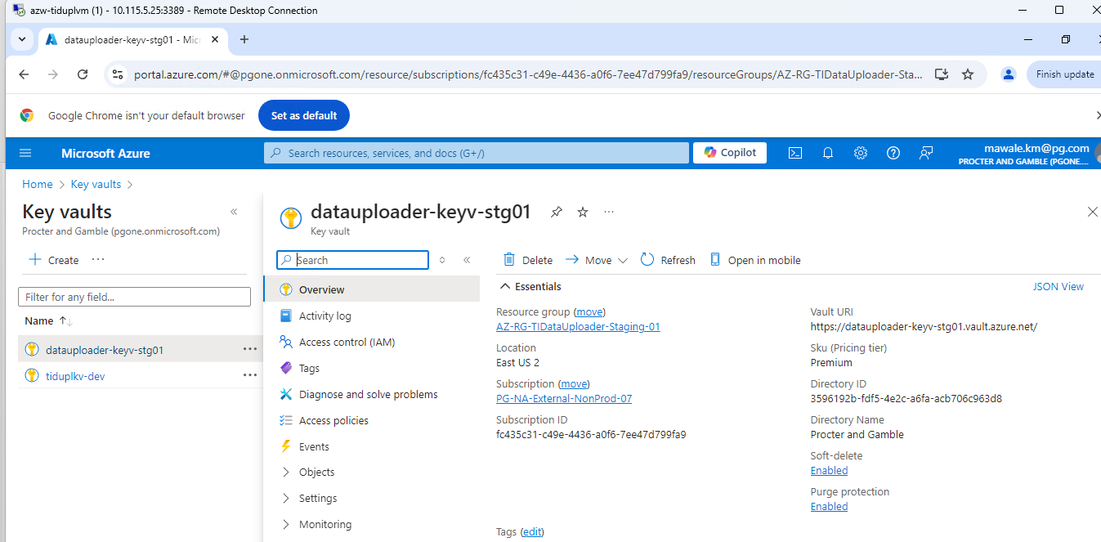

Step 3. Open object item on left pane and select secret

Step 4. Select Generate/ import

Step 5: Provide the secret name and value

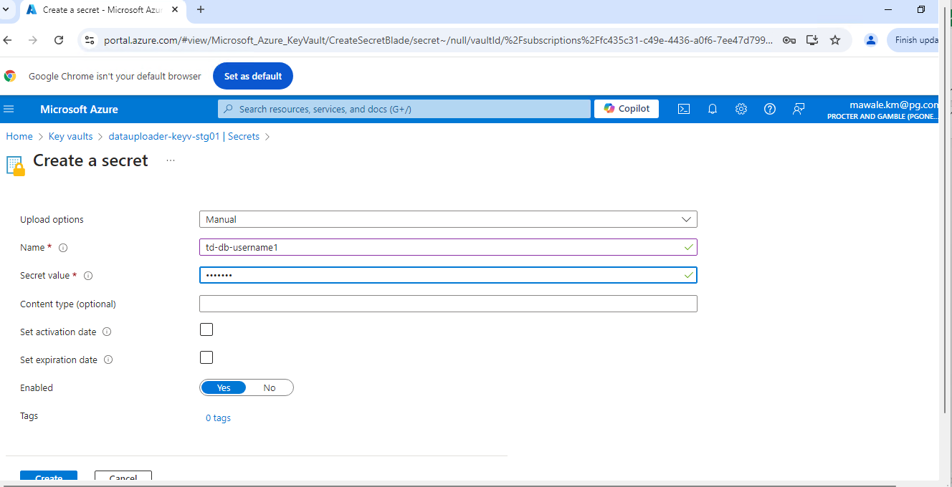

Step 6: Click on create

Similarly every secret which is required can be created by same steps, only the difference is values provided needs to be according to the secret.

# Setting up Azure Data Bricks

Step 1: login to azure portal and select azure data bricks.

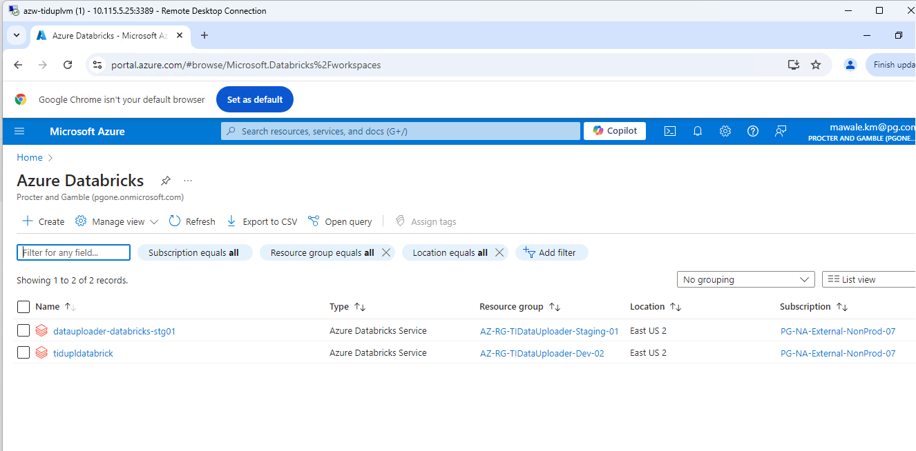

Step 2: Select Desired data bricks environment and click on Launch

Step 3. First scope needs to be created in ADB,

First go to https://<databricks-instance>#secrets/createScope. Replace <databricks-instance> with the [workspace URL](https://learn.microsoft.com/en-us/azure/databricks/workspace/workspace-details#workspace-url) of your Azure Databricks deployment. This URL is case sensitive (scope in createScope must be uppercase).

Step 4: Enter the name of the secret scope. Secret scope names are case insensitive.

Step 5: Use the Manage Principal drop-down to specify whether *All Users* have MANAGE permission for this secret scope or only the *Creator* of the secret scope (that is to say, you).

Step 6: Enter the DNS Name (for example, <https://databrickskv.vault.azure.net/>) and Resource ID and click on create.

Step 7: After this cluster needs to be created, click on compute and on right hand side click on create compute

Step 8: now provide cluster name and other configuration as required, now cluster is created.

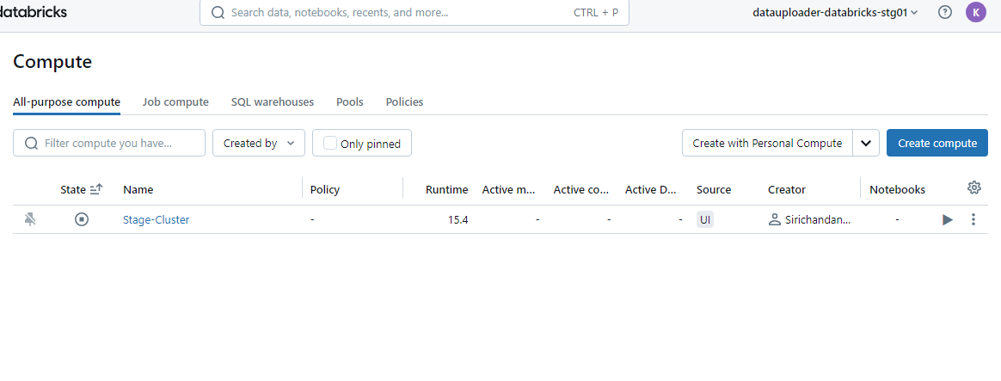

Step 9: at last, click on create compute on bottom , cluster is now created.

Step 10: cluster is now created.

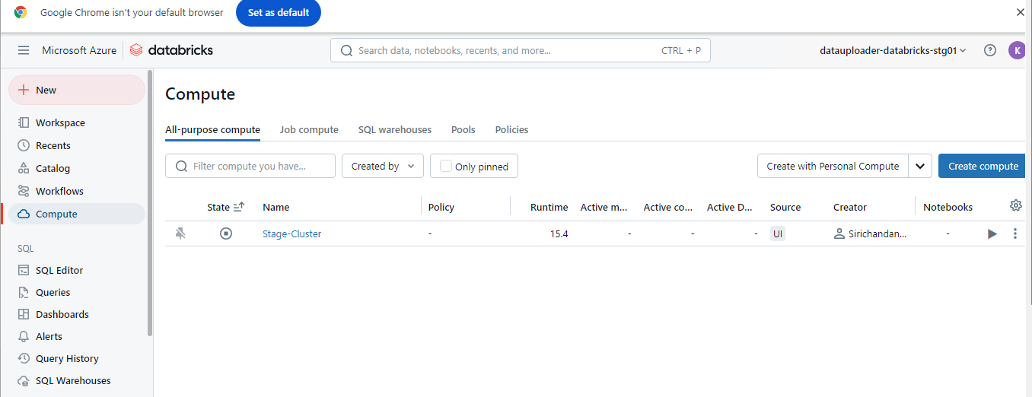

Step 11: now next part is to create mount for storage account.

Create new notebook and write mounting related code snippet

Is everything goes fine you can able to mount related with storage account.

# ADF Setup

Step 1: open azure portal and select desired data factory and click on launch studio.

Step 2: now in ADF we need to create Linked services and data sets to configure ADF.

Click on manage tab on left pane

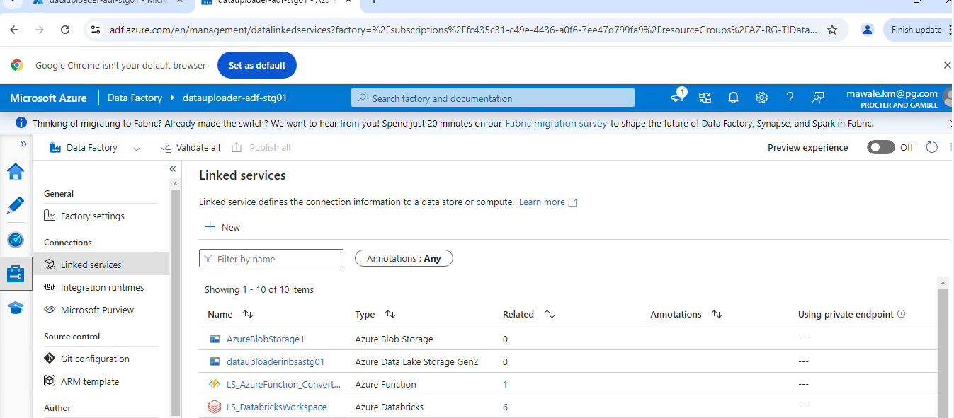

Step 3: Click on +new and select type of data service needs to be created

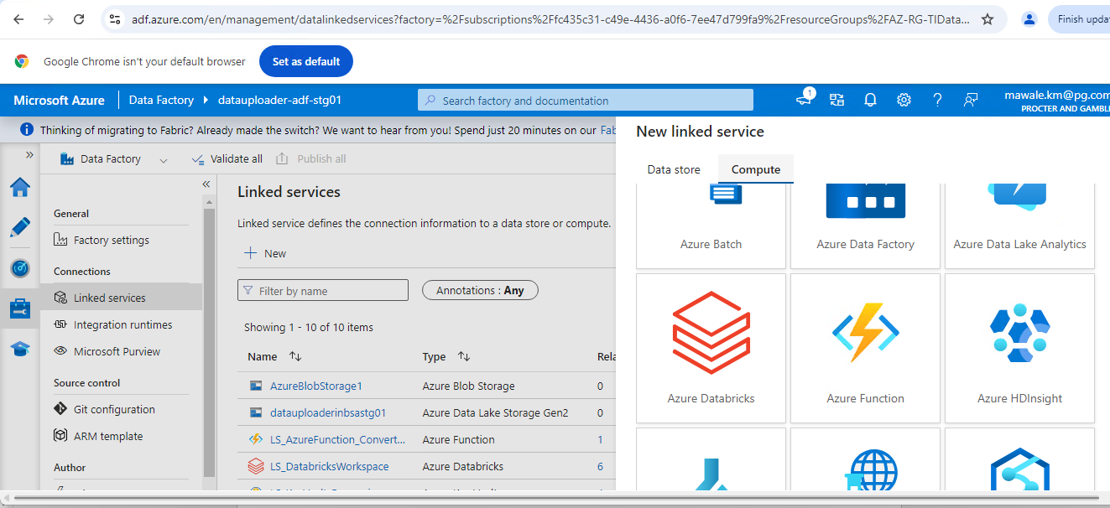

Step 4:

Provide details like, name, subscription, identity description etc

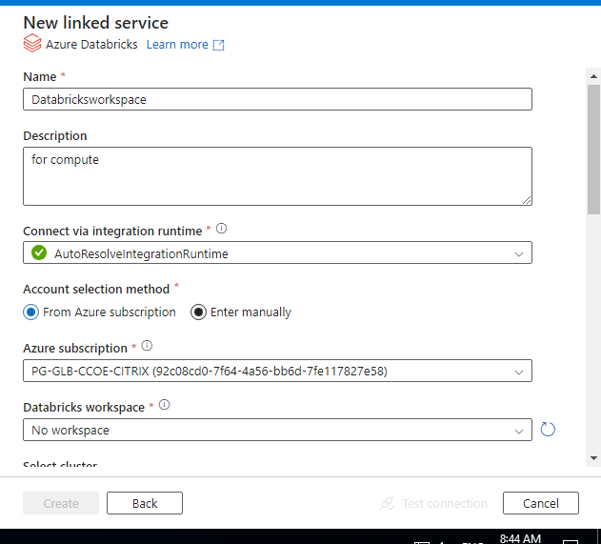

Step 5: click on create and test connection, like wise create every needed linked services with details required .

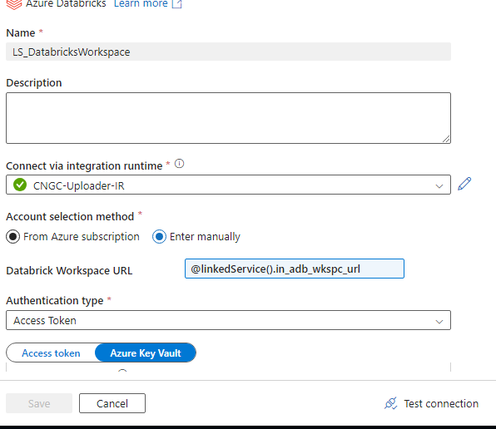

Step 6: Now click on author tab on left pane and select data set

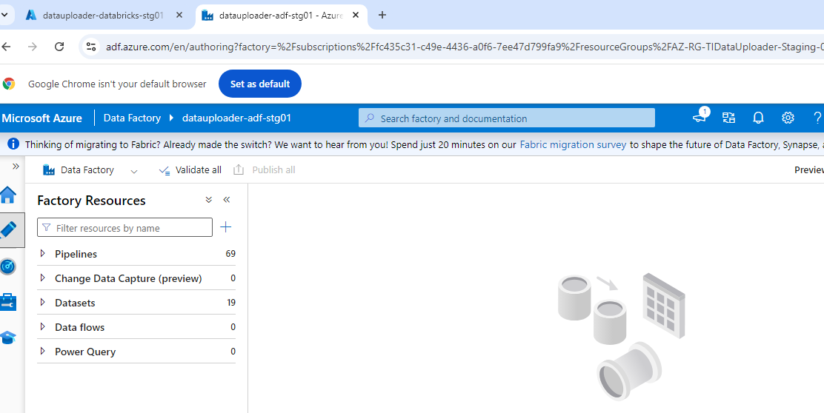

Step 7: click on new data set

Step 8: select format

Step 9: provide the details

Step 10: click on ok

# SQL Setup

* **User and Role Management**

**Query to Retrieve All Roles and Users**

SELECT u.name AS UserName, r.name AS RoleName

FROM sys.database_principals u

JOIN sys.database_role_members rm ON u.principal_id =rm.member_principal_id

JOIN sys.database_principals r ON rm.role_principal_id = r.principal_id ORDER BY u.name, r.name;

**Creating a Login**

CREATE LOGIN <loginname>

WITH PASSWORD = '<your_password>';

**Creating a User**

CREATE USER <username>

FOR LOGIN <loginname>;

GO

GRANT CONNECT TO <username>;

**Adding a Role**

CREATE ROLE <role_name> AUTHORIZATION [dbo];

GO

ALTER ROLE <role_name> ADD MEMBER <username>;

GO

* **Sequence Initialization**

**Query to Select All Sequences**

SELECT

SCHEMA_NAME(schema_id) AS SchemaName,

name AS SequenceName

FROM

sys.sequences

ORDER BY

SchemaName, SequenceName;

**Creating a Sequence**

CREATE SEQUENCE [schema_name].[seq_name]

AS [bigint]

START WITH 1

INCREMENT BY 1

MINVALUE -9223372036854775808

MAXVALUE 9223372036854775807

CACHE 10;

GO

* **Metadata Initialization**

**Query to Retrieve All Tables**

SELECT

schema_name(t.schema_id) AS schema_name,

t.name AS table_name

FROM

sys.tables t

ORDER BY

schema_name, table_name;

**Query to Retrieve All Views**

SELECT

schema_name(v.schema_id) AS schema_name,

v.name AS view_name

FROM

sys.views v

ORDER BY

schema_name, view_name;

**Query to Retrieve All Stored Procedures**

SELECT

schema_name(p.schema_id) AS schema_name,

p.name AS procedure_name

FROM

sys.procedures p

ORDER BY

schema_name, procedure_name;

* **Implementation Steps**

**Create Necessary Tables, Views, and Stored Procedures**

* Use the provided SQL scripts to create the required database objects.

**Execute Metadata Scripts**

* + After creating the tables, views, and stored procedures, run the metadata queries in the specified order.
  + Make necessary modifications to match your specific table names, view names, stored procedure names, or sequence values.
  + Once all scripts execution is completed please verify all metadata tables and insert values into them manually if any of them are missed during scripts execution.



# RITM’s raised for whitelisting



# Issues

